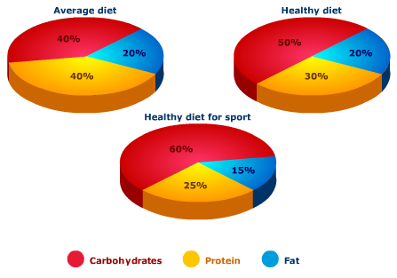
Fill the gaps with these words:
constitutes, drops, amount, fifth, higher, make, one, relative, figure, up
The pie charts compare the proportion of carbohydrates, protein and fat in three different diets, namely an average diet, a healthy diet, and a healthy diet for sport.
It is noticeable that sportspeople require a diet comprising a significantly higher proportion of carbohydrates than an average diet or a healthy diet. The average diet contains the lowest percentage of carbohydrates but the highest proportion of protein.
Carbohydrates ______ ______ 60% of the healthy diet for sport. This is 10% ______ than the proportion of carbohydrates in a normal healthy diet, and 20% more than the proportion in an average diet. On the other hand, people who eat an average diet consume a greater ______ ______ of protein (40%) than those who eat a healthy diet (30%) and sportspeople (25%).
The third compound shown in the charts is fat. Fat ______ exactly ______ ______ of both the average diet and the healthy diet, but the ______ ______ to only 15% for the healthy sports diet.

